MENU LAVANDIN :

50 with cheese AND dessert
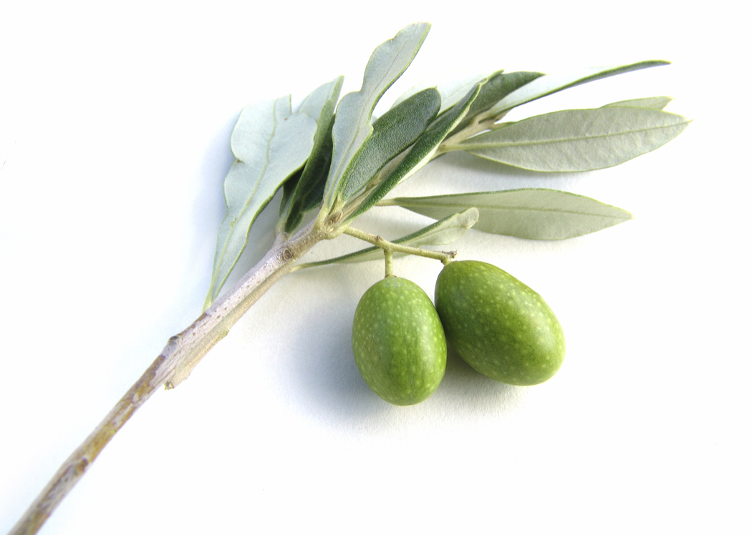
La mise en bouche du moment.
Mise en bouche of the moment.
Melon de Provence et copeaux de cochon « Rougeot du Charvin » de Doussard 22.
Provence melon and dry cured ham from a unique local breed of pigs.
OU / OR
« Tami'flette » croustillante et velouté au Tamié de l'abbaye 18.
Crispy Tamié cheese tartiflette in a velouté made with abbey cheese
from the Tamié Abbey.
Féra sauvage du lac d'Annecy (Manu Clerc) oseille de notre jardin et beurre des Moines 26.
Wild-caught fera fish served accompanied with garden sorrel and abbey butter from the Tamié Abbey.
OU / OR
Roulade d'agneau de Savoie, provençale de légumes et jus au thym 35.
Roll of local lamb served with its own thyme-infused juice and a Provençal vegetable medley.
44 with cheese OR dessert
Any dish from the Lavandin menu can also be ordered from the main menu as well as
from the Farigoule and the Garrigue menu!
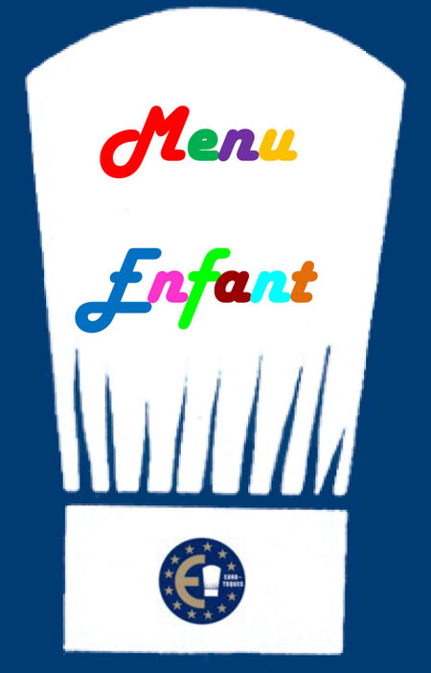 | CHILDREN'S MENU 16.  This menu is exclusively prepared with all natural fresh local produce. It contains little salt and little sugar. No chips!  Main course (meat or fish) and accompaniment + ice cream.
MENU CIGALOU : 36
Your choice of a starter from the Lavandin menu + your choice of a main course
from the Lavandin menu
OR
Your choice of a main course from the Lavandin menu and our selection of Savoy cheeses
OR
Your choice of a main course from the Lavandin menu and today’s special dessert

All our prices are net and inclusive of tax (service is included).
A full allergy list is available on request

