A LA CARTE
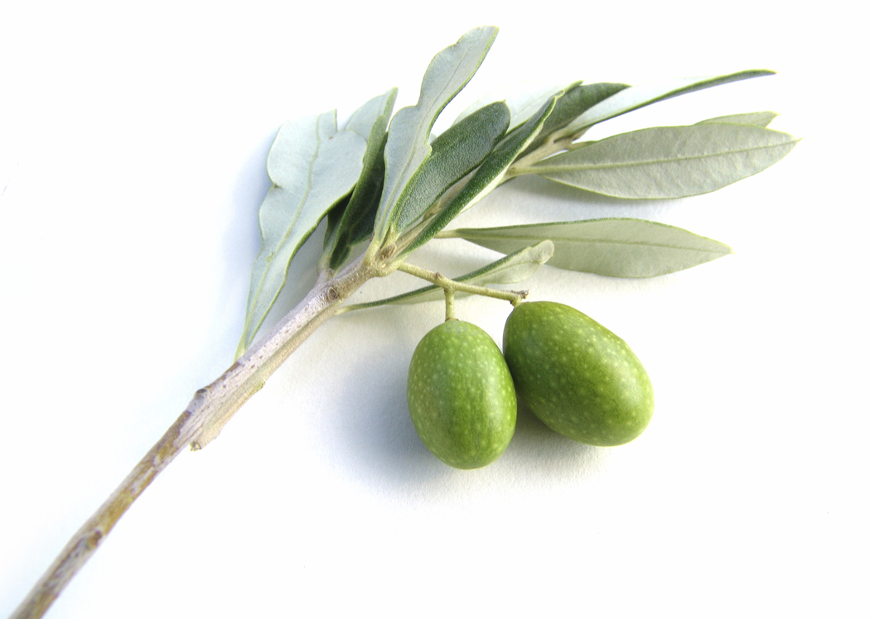
Terrine de perdreaux, cèpes, foie gras et Banyuls,
salade, truffes grises des Bauges 34.
Partridge, porcini mushrooms and Banyuls foie gras terrine served with truffle salad made with local grey truffles
Tatin de St Jacques, céleri et truite fumée, sorbet d'huîtres 26.
Scallop, celery and smoked trout tarte tatin pie with oyster sorbet
Poêlée de foie gras de canard, poires,réglissechocolat et Balsamico
Panned duck foie gras on a bed of liquorice pears,
chocolate and a hint of balsamic vinegar 38.
Parmentier de gibiers « Plumes », foie gras,
sauce Porto et truffes grises 26.
Parmentier of wild feathered game and foie gras with Port sauce and grey truffles
Poêlée de St Jacques au beurre de Tamié,
blanquette de légumes d'automne 38.
Scallops panned in abbey butter from the Tamié Abbey accompanied with autumn vegetable blanquette
Contre-filet de bœuf «France» crème aux poivres 40.
Local beef sirloin steak with pepper cream sauce elaborated from diverse varieties of pepper
Noisettes de chevreuil à la Grand Veneur, panais aux noisettes 45.
Deer medallion in Grand Veneur sauce accompanied with parsnip purée and hazelnuts
Filet de râble de lièvre, à la Mondeuse et chou pormonier à la châtaigne 38.
Hare saddle fillet served with red wine sauce elaborated from the local Mondeuse wine variety – accompanied with pormonier cabbage and chestnuts

